EUCLID VIEW FLATS
234-238 Bates Avenue
Saint Paul, Minnesota 55106

September 18, 2014
Elizabeth Gales, Hess, Roise and Company
New Plans were received; dated 11-12-14. Not all of the information below is current

PROJECT DESCRIPTION
Introduction
Euclid View Flats is a three-story apartment building located at 234-238 Bates Avenue in the
Dayton’s Bluff Historic District. The property is on the southeast corner of the intersection of Bates Avenue and Euclid Street. The building is set back from the street on a lot that slopes upward. The exterior is clad in red brick with brownstone and limestone window sills. The windows are non-historic, wood-frame, one-over-one sash. The first-story window openings on the west and north facades are arched and hold either fixed plate-glass windows with transoms or one-over-one sash windows. Two-story oriel windows run between the second and third floors of several bays on the east and north facades. Historic porches on the front facade were replaced in the twentieth century with concrete stoops. A large non-historic, wood-frame fire escape is attached to the east wall. Twelve apartment units, four on each floor, are housed in the property.

The property is vacant and is owned by the City of Saint Paul. The city is going to sell the property to Sand Companies, which will rehabilitate the building. The twelve apartment units will be renovated and rented as affordable units. A detailed scope of work is listed below.

Scope of Work
Item 1
Feature: Exterior Masonry
Date of feature: 1895, later alterations
Describe existing feature and its condition:
The building is three stories above a limestone foundation. The west facade is visually divided
into north (238 Bates Avenue) and south (234 Bates Avenue) halves that are each three bays wide. All walls are constructed of red brick in a stretcher-bond. In general, the masonry is in good condition. The two-story oriel windows on the east facade have stone sills that are in good condition. On the front, west-facing facade, the original porches were removed in 1946. The profile of the porches is visible on the foundation where the limestone foundation is exposed. Some of the stone has been covered with tinted concrete. In the light well, lichen has grown on the stone foundation and sills.
Photo No.: 1-3, 5-6, 8-11
Drawing No.: A7.0-A7.1
Describe Proposed Work: No masonry repair work is planned as part of the project.

Item 2
Feature: Windows
Date of feature: Twentieth century
Describe existing feature and its condition: The windows on the lower stories have been boarded up because the building is vacant. The windows are non-historic, wood-frame, one-over-

one sash. The first-story window openings on the west and north facades are arched and hold either fixed plate-glass windows with transoms or one-over-one sash windows. The wood jambs are in good condition except in the light well at the rear of the building where moisture and moss growth has deteriorated the wood. The majority of the glass has been broken in the windows and several non-historic sashes have also been damaged. Security bars have been installed over the windows on the east elevation overlooking the fire escape.
Photo No.: 1, 3-4, 6, 8, 11, 101, 121
Drawing No.: A2.0, A2.2, A2.4, A2.6, A7.0-7.1, A13.1, A13.3
Describe Proposed Work: The existing wood frames in the openings will be retained. The non- historic sashes will be replaced with new double-hung, aluminum-clad, wood-frame sashes. The size and profile of the new sashes will complement the historic character of the building. The insulated glazing in the sashes will be clear with no tinting. The exterior of the frames and sashes will be painted a dark-green color that will match other dark-green trim on the building. The interior of the frames will be painted white.

Item 3
Feature: Oriel Windows
Date of feature: 1895, later alterations
Describe existing feature and its condition:
Two-story oriel windows run between the second and third floors of several bays on the east and
north facades. The projecting sections are wood framed and clad in metal that is in good condition with some peeling paint. Fields of metal stars attached to the metal panels are also in good condition. The original window units have been replaced with wood-frame, one-over-one units. The window frames are in good condition.
Photo No.: 4
Drawing No.: A2.4, A2.6, A7.0, A13.1, A13.3
Describe Proposed Work: The metal sections of the oriel windows will be repainted dark green and the decoration will be painted cream and dark yellow. The existing wood frames in the openings will be retained. The non-historic sashes will be replaced with new double-hung, aluminum-clad, wood-frame sashes. The size and profile of the new sashes will complement the historic character of the building. The insulated glazing in the sashes will be clear with no
tinting. The exterior of the frames and sashes will be painted a dark-green color that will match other dark-green trim on the building. The interior of the frames will be painted white.

Item 4
Feature: Front Entrances
Date of feature: Twentieth Century
Describe existing feature and its condition: There are two entrances on the west facade overlooking Bates Avenue. The openings are topped by brick round arches, and hold non- historic metal doors and wood paneling.
Photo No.: 2-3
Drawing No.: A7.0, A13.0-A13.2
Describe Proposed Work: The non-historic doors and wood paneling will be removed. New fiberglass frames and doors will be centered in each opening. The upper and lower sections will have raised decorative panels and decorative insulated glazing will be installed in the upper

panel. Sidelights with insulated glazing will flank the doors, and the transoms will hold insulated glass that follows the shape of the round arches. All of the glazing will be clear with no tinting.

The entry design has been revised since this document was submitted. The style now relates to the existing historic vestibule details and the materials are wood.

Item 5
Feature: Stoops
Date of feature: Mid-twentieth century
Describe existing feature and its condition: Non-historic concrete stoops are located at each entrance bay on the west elevation. Iron handrails run up each side of the stairs. Historically, wood porches were located at the entrances. A historic photograph of the building (Photo 121) shows the porches, and the outline of the porch bases can be seen on the west wall where the stone foundation is exposed on either side of the non-historic stoops.
Photo No.: 2-3, 121
Drawing No.: A7.0, A11.0-A11.2
Describe Proposed Work: The non-historic concrete stoops and railings will be removed. New, wood-frame stoops that match the footprints of the historic porches will be constructed. The walls of the stoops will have decorative wood panels similar to those visible in the historic photograph of the building. The wood stairs and turned spindle handrails will also be similar to those in the photograph. The stoops will be painted to complement the wood trim on the rest of the building. No roof structures are planned.

Item 6
Feature: Roof
Date of feature:
Describe existing feature and its condition: The roof is flat and covered with a built-up roof
system that contains asbestos. Brick parapet walls wrap around all sides and the membrane system wraps up and over the parapet walls. Roof drains lead to pipes that run through partition walls to the basement. A chimney projects above the roofline on the east side.
Photo No.:
Drawing No.: A3.0-A3.1
Describe Proposed Work: The existing roof drains will be replaced with new drains and lines that are concealed within the walls and empty in drains in the basement. The existing built-up roof and roofing will be removed and replaced with a new EPDM roof system. At the parapet walls, the membrane will run up the sides of the walls and new metal caps will cover the tops of the parapets. The metal caps will be visible on the east and south walls but will be pre-finished in
a color that matches the brick on the walls. Condensers for the HVAC system will be installed on the roof surrounding the light well. The units will be 35″ wide, 35″ tall, and 12″ deep, and will be set back from the edge of the roof so that they will not be visible from the ground.

Item 7
Feature: Fire Escape/Access Staircase
Date of feature:
Describe existing feature and its condition: A non-historic wood fire escape system spans the
entire east elevation. Wood decks are part of the fire escape system on the second and third stories.
Photo No.: 7
Drawing No.: D1.1-D1.3, A7.1, A12.1

Describe Proposed Work: The non-historic wood fire escape will be removed. Another means of egress is required on the east facade, and new steel access staircases will be installed for each stack. The staircases will have wire-mesh panels picket-style tube metal at all of the handrails. On the south stack, a ladder will extend from the third-floor staircase to the roof. All of the steel will be finished with paint in a neutral color. The footprints of the staircases will be kept as small as possible while complying with code.

Item 8
Feature: Cornice
Date of feature:
Describe existing feature and its condition: A bracketed, pressed-metal cornice runs along the
west and north facades with a small return on the east elevation. The cornice is in good condition with minimal flaking paint. The existing membrane roofing has been extended over the top of the cornice. The membrane also covers a non-historic substructure that has been constructed behind the cornice to raise the elevation of the roof.
Photo No.: 1, 4-5
Drawing No.: A3.1, A7.0
Describe Proposed Work: The existing membrane roofing, metal flashing, and non-historic substructure will be removed from the top and rear sides of the cornice. New low-profile treated framing will be installed on top of the cornice to create a slope that will carry water away from the cornice. A new membrane roof and a new metal cap will be installed over the top of the cornice and down the back side. The metal cap will not be visible from the ground. The cornice will be repainted dark green to match the rest of trim on the building.

Item 9
Feature: Light well access and basement doors
Date of feature: Twentieth century
Describe existing feature and its condition: The light well can be accessed from the east side of the of the property through a non-historic wood gate. Rotting wood steps lead from grade down to the floor of the light well, which is unpaved. Doorways into the basement on the north and south walls of the light well hold non-historic metal doors and security doors with bars. Photo no.: 9
Drawing no.: D1.0, A1.1, A2.0, A12.1, A13.0-A13.1
Describe proposed work: The non-historic wood gate and steps will be removed. A new metal chain-link gate and a new metal ladder will be installed. The non-historic metal doors, frames, and security doors will be removed. New hollow, metal doors and frames will be installed in both doorways. The doors and frames will have a painted finish in a neutral color.

Item 10
Feature: Basement windows
Date of feature: Twentieth century
Describe existing feature and its condition: The basement windows are covered with plywood. The condition of the window frames and sashes is unknown.
Photo no.: 9
Drawing no.: D1.0, A2.0, A7.0-A7.1, A13.1

Describe proposed work: The plywood will be removed. If the windows and frames are extant, they will be removed and the openings will be filled with brick. The brick will be recessed so the profile of the original window opening will be visible.

Item 11
Feature: Site
Date of feature: 1895, later alterations
Describe existing feature and its condition: The building sits above street level on a lot at the southeast corner of Euclid Street and Bates Avenue. On the west side facing Bates Avenue, a concrete staircase leads from the public sidewalk up the graded yard to another concrete
sidewalk and then forks to the two entrances. The graded yard wraps around the north side of the lot. The land on the east side of the property has been covered in asphalt, including a driveway that slopes down to the street. A sloped, asphalt retaining wall runs along the east property line. The building sits on the south property line and a single-family house is immediately to the
south. A mature tree is located at the southwest corner of the property and several other trees reside in the boulevard and on neighboring properties.
Photo no.: 1, 5, 7
Drawing no.: A1.0-A1.2
Describe proposed work: The non-historic sidewalks on the west side of the building will be replaced with new concrete walks. On the east side, the asphalt will be removed. A new concrete slab will be poured for a patio behind the building. Open areas for plantings will be incorporated into the patio. The plants will include arborvitae shrubs, ferns, chokeberry, and ornamental grasses. Furnishings, including a bench, picnic table, and bike racks will be installed on the east side. A trash enclosure enclosed by a chain-link metal picket-style fence will be built at the northeast corner of the site. Gates on the north side of the enclosure will provide access to the dumpsters. The existing curb-cut for the driveway will be widened to allow for garbage truck access. A new concrete drive will be poured leading from the street to the trash enclosure.

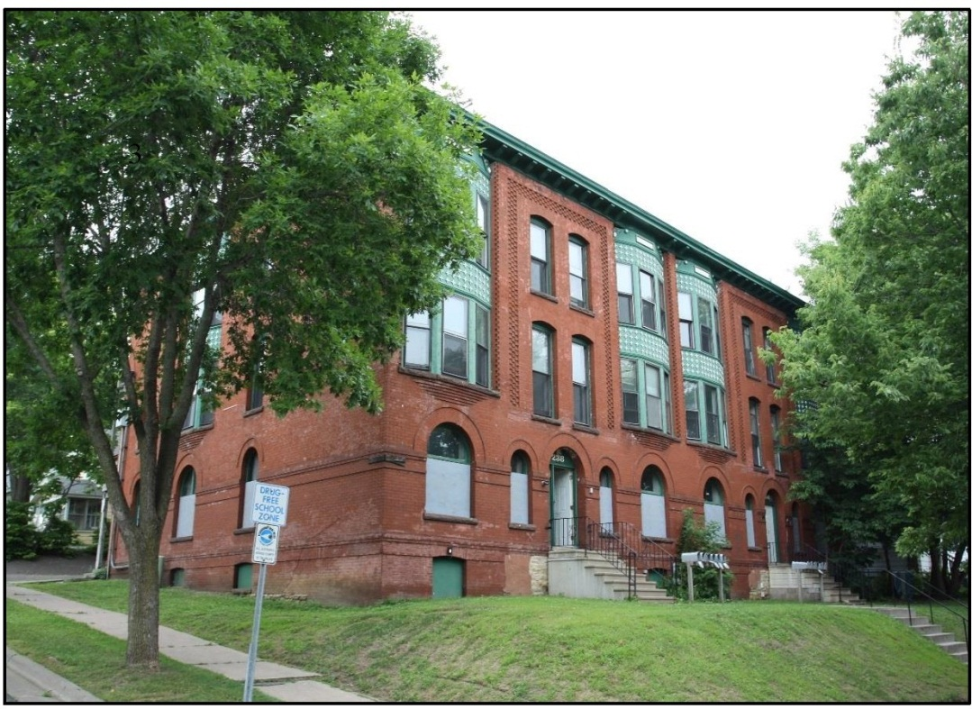
Photo 1 (May 14, 2014) View: North (left) and west (right) facades, view southeast
Description: View of the primary facades overlooking Bates Avenue (right) and Euclid Avenue (left)

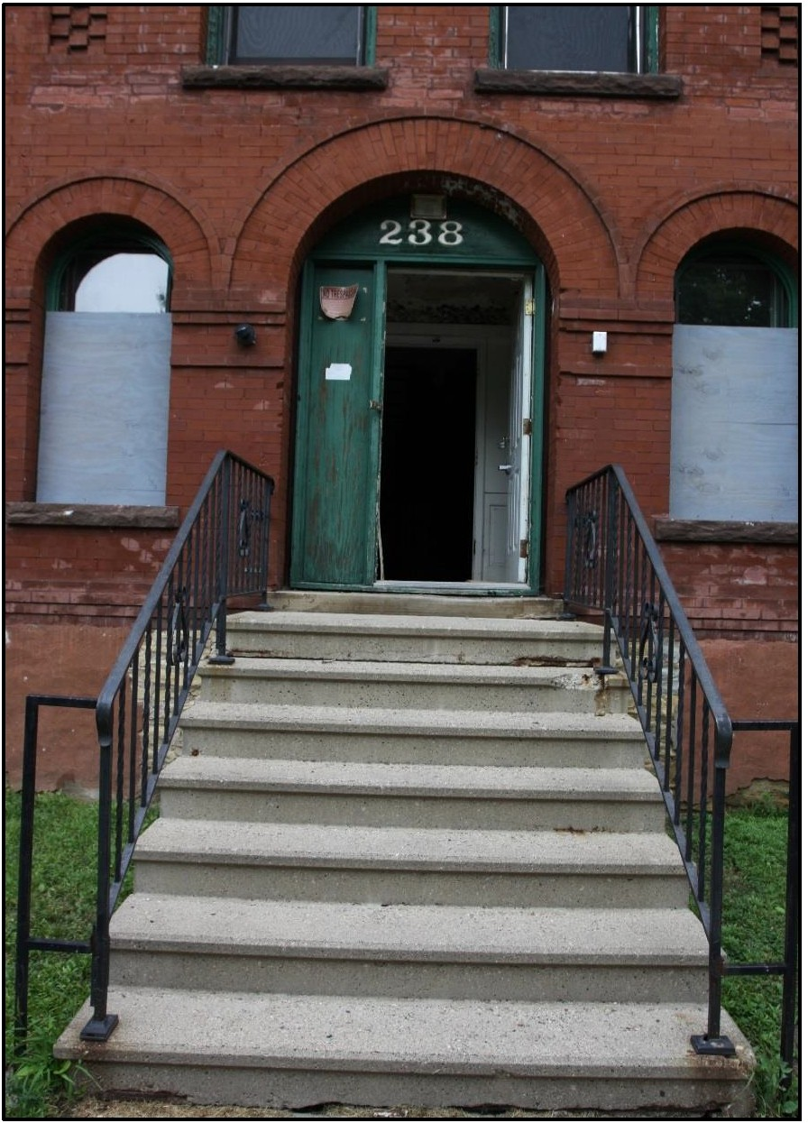

Photo 2 (May 14, 2014)
View: Entrance, west facade, looking east Description: View of the non-historic stoop and entryway

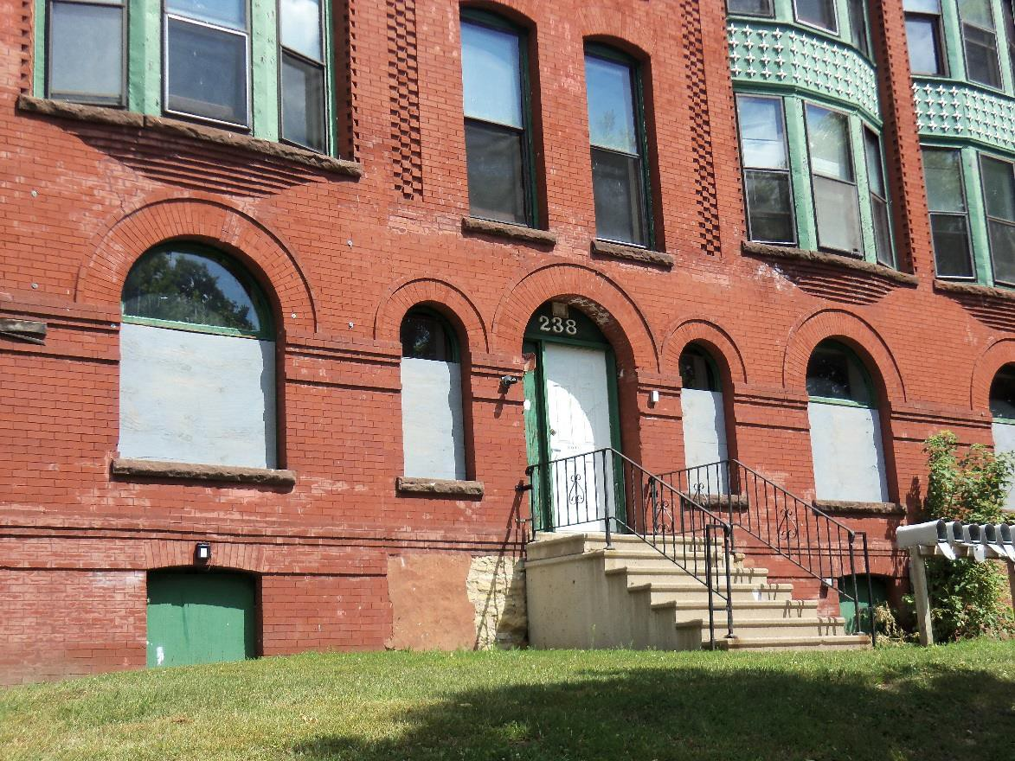
Photo 3 (July 31, 2013) View: West facade, windows and entrance, view southeast Description: Detail of the entryway on the west facade; the historic porch profile is visible on the foundation

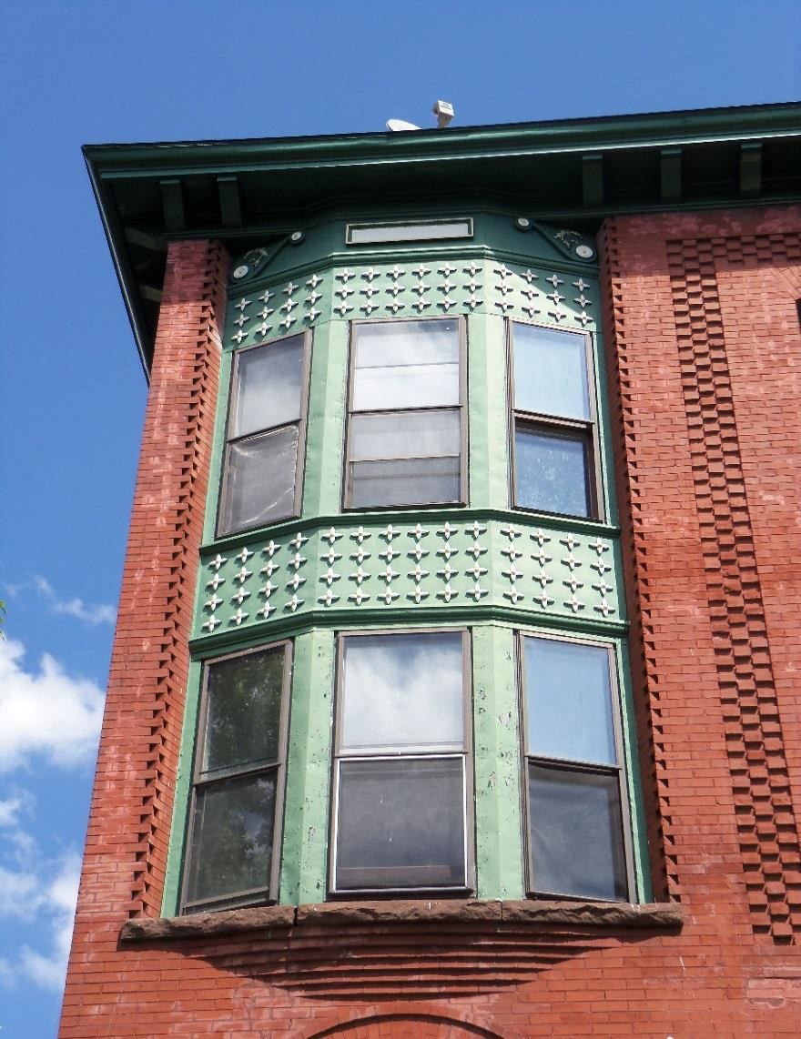

Photo 4 (August 17, 2013)
View: Oriel windows, west facade, view east
Description: Detail of the oriel windows on the west facade; typical of all of the oriel windows

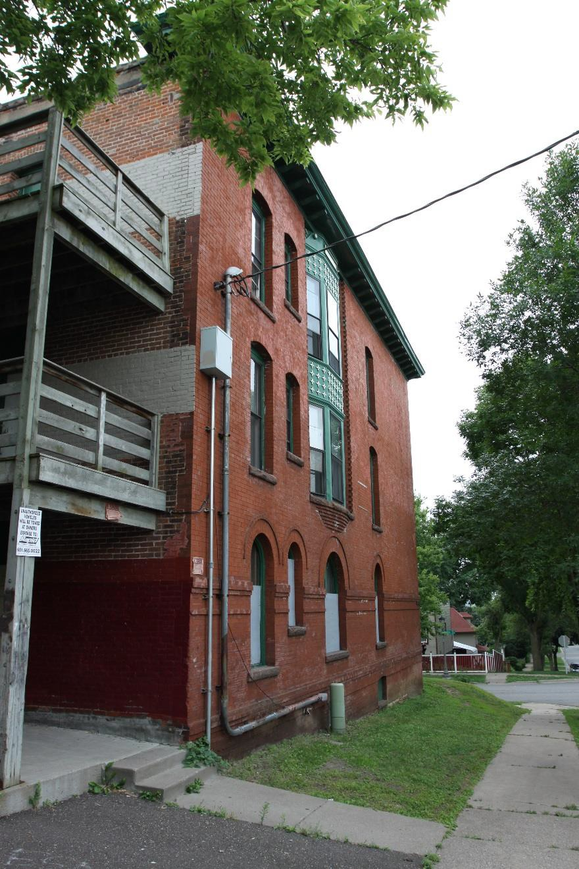
Photo 5 (May 14, 2014)
View: North facade, view southwest
Description: View of the north facade

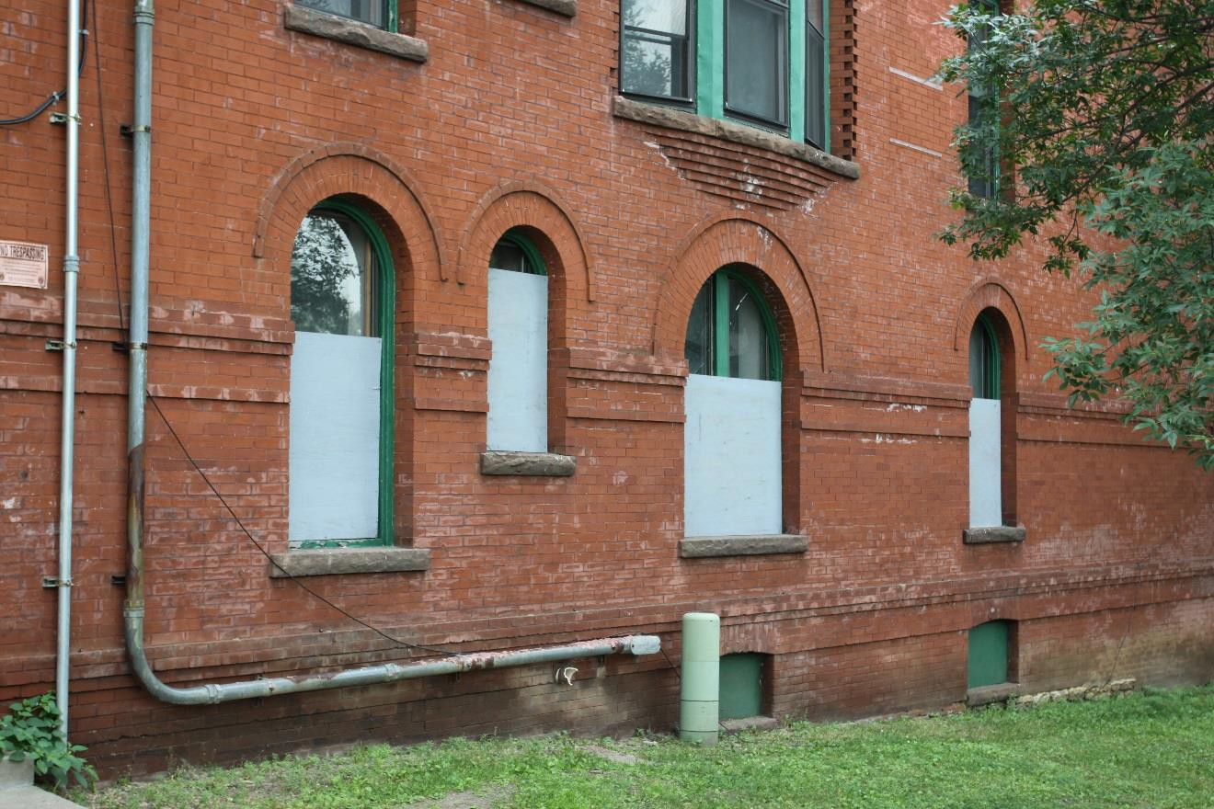

Photo 6 (May 14, 2014) View: First-story windows, north facade, view south
Description: Detail view of the arched windows on the north facade

Photo 7 (May 14, 2014)
View: East facade, view southwest Description: View of the east facade and the non-historic fire escape

Photo 8 (May 14, 2014)
View: East facade, light well, view west Description: View of the upper floors of the light well

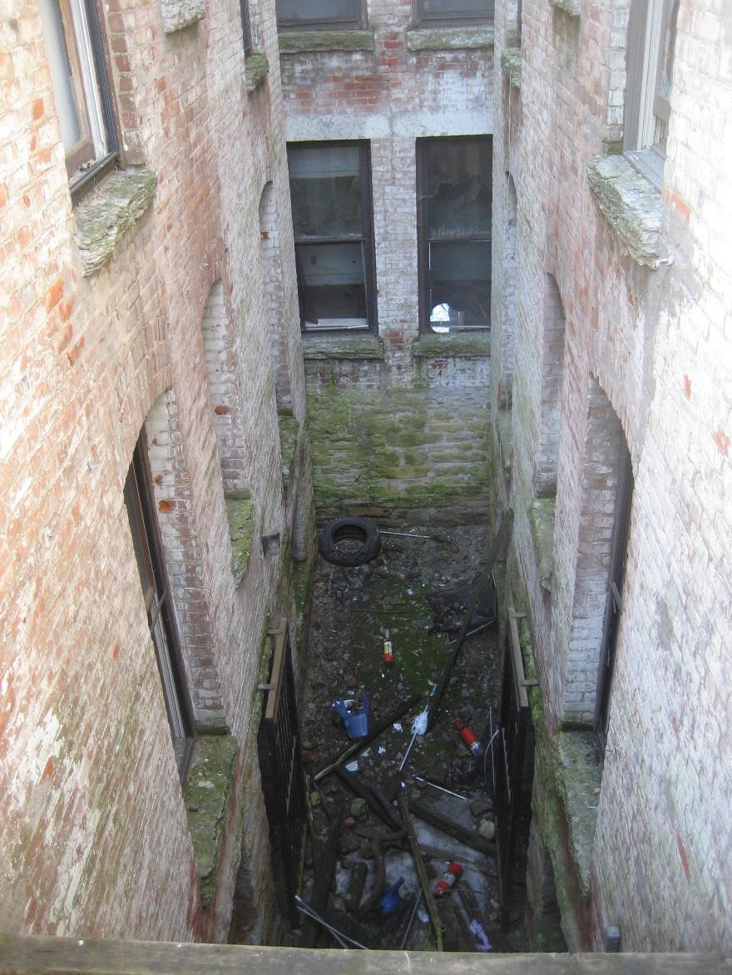
Photo 9 (May 14, 2014)
View: East facade, light well, view west
Description: View of the lower floors and ground of the light well

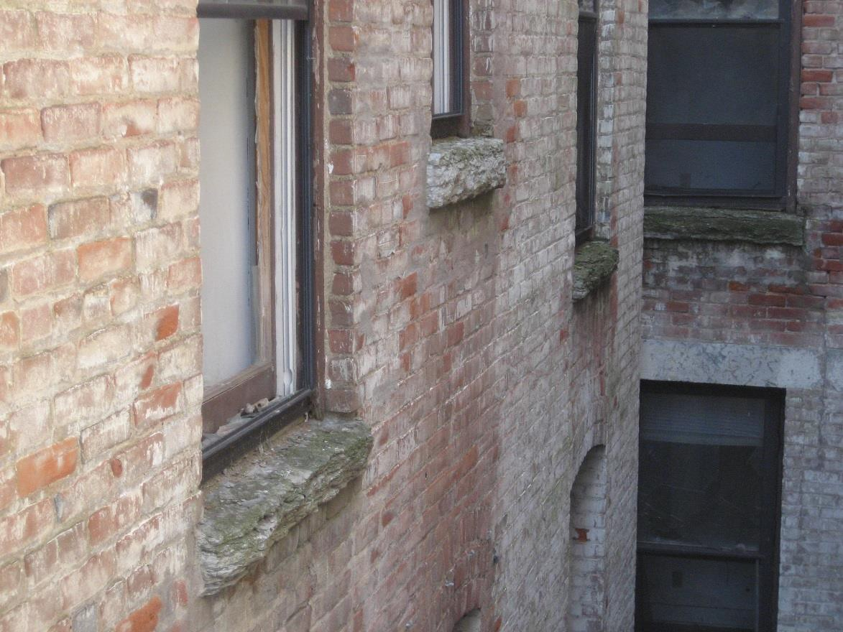

Photo 10 (May 14, 2014) View: South facade of light well, view southwest Description: Detail view of the masonry and stone sills in the light well

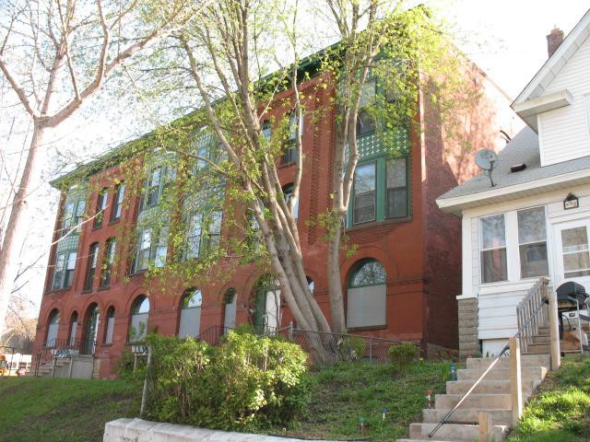
Photo 11 (May 14, 2014) View: West (left) and south (right) facades, view northeast
Description: Portion of the south facade visible at
right; the south facade is mostly concealed by the neighboring property

