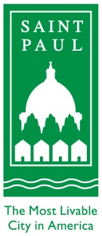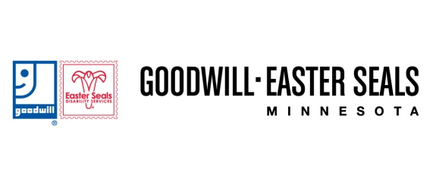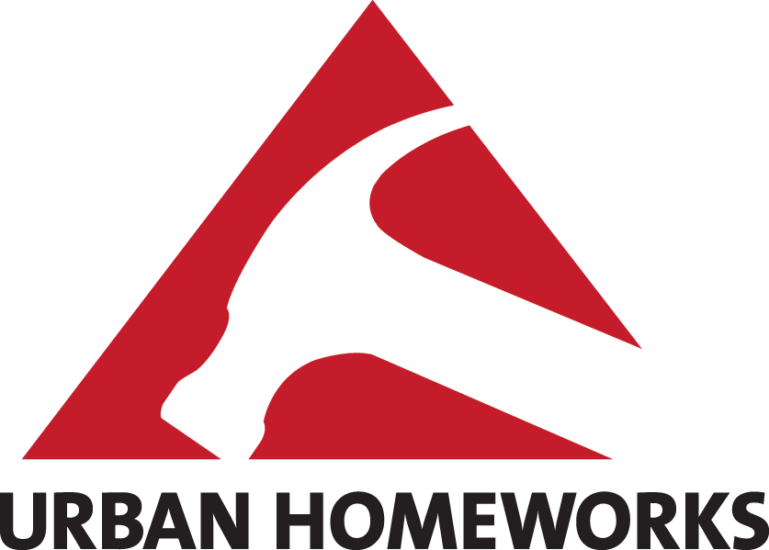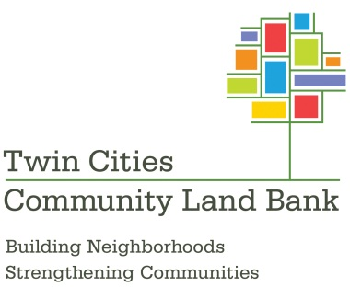

FOR IMMEDIATE RELEASE
July 25, 2013

Contacts:
Alex Dumke, City of Saint Paul, 651-266-8969
Sara Swenson, City of Saint Paul, 651-266-6575
Lisa Ritter, Goodwill/Easter Seals Minnesota, 651-379-5927
Jessica Mueller, Urban Homeworks, 612-232-0394
Sandra Oakes, Twin Cities Community Land Bank, 612-238-8210

City of Saint Paul Provides Resources for
Job Training and Housing Initiative
Partners include Goodwill/Easter Seals Minnesota, Urban Homeworks and Twin Cities Community Land Bank

SAINT PAUL - The City of Saint Paul has entered into a partnership with Goodwill/Easter Seals Minnesota, Urban Homeworks, and the Twin Cities Land Bank to provide construction training to low-income residents who will construct new homes in Saint Paul’s Frogtown neighborhood.

To make this happen, Saint Paul’s Human Rights and Equal Economic Opportunity (HREEO) Department provided $200,600 to expand the Goodwill/Easter Seals Minnesota construction training program. This will increase their program to 200 participants annually. The Saint Paul Housing and Redevelopment Authority (HRA) is selling vacant lots to Urban Homeworks where new affordable, owner-occupied single-family homes will be built by the Goodwill/Easter Seals construction training participants. Construction and gap financing is being provided by Twin Cities Community Land Bank and the Saint Paul HRA. The new homes will conform to the Energy STAR and Minnesota Green Communities standards for new construction.

“This is a perfect example of multiple organizations coming together to revitalize neighborhoods and give Saint Paul residents a boost into a construction career,” said Saint Paul Mayor Chris Coleman. “The Frogtown community and the entire city benefits by getting city-owned properties back on the tax rolls and incorporating sustainable building standards.”

“This initiative is a huge win for Frogtown, a neighborhood hit hard during the recession and foreclosure crisis,” said HRA Commissioner Nathaniel Khaliq. “I want to thank all partners involved including the Frogtown Neighborhood Association that played a key role in getting residents to participate in the construction training program. It’s exciting to see all of the local participation that is helping rejuvenate our neighborhoods.”

The Goodwill/Easter Seals Minnesota construction training program includes 12 weeks of combined classroom and hands-on instruction to prepare participants for a career in the construction trades. The training program targets low-income women and minority residents who face various obstacles to gainful employment. At the conclusion of the program, participants graduate with an OSHA 10 safety certification, earn lead abatement worker certification, and earn 36 continuing education units from Saint Paul College.
“This partnership is truly a win-win for Saint Paul residents,” said Dr. Michael Wirth-Davis, President and CEO of Goodwill/Easter Seals. “Not only will our students build new homes, but Saint Paul will gain 100 new skilled carpenters, roofers and finishers who are ready to hit the job market running. We are looking for students who want to experience the professional production expected from employers with this real-world paid training.”

Following construction, Urban Homeworks will market and sell the newly constructed homes to an income-qualified household. The Saint Paul HRA will also provide homebuyer assistance incentives of up to $5,000 depending on household income.

“We are grateful for the chance to deepen our existing collaborations with our partners to the multidimensional benefit of our community,” said Chad Schwitters, Urban Homeworks President. “We hope this might energize many more collaborations across our region that consciously and deliberately weave the economic investments in housing with the economic self-determination of our neighbors.”

###

About Goodwill/Easter Seals Minnesota
Goodwill/Easter Seals Minnesota provides family strengthening, education, workforce development and employment services for people with disabilities and other barriers to education, employment and independence. In the past year, over 15,600 individuals received 70,280 services, including job skills training (automotive, medical office, banking/finance, construction and retail), job placement and free medical equipment loans. Revenues from its 30 retail stores, along with other contributions, support these programs at 32 service locations in Minnesota. For more information visit www.goodwilleasterseals.org

About Urban Homeworks
Since 1995, Urban Homeworks has been responding to the voices of our neighbors by providing dignified housing opportunities, creating space for construction training, intentionally weaving together a network of engaged neighbors, and mobilizing volunteers. Our focus on stability and connecting resources so that individual and communal assets emerge, thrive, and invigorate our neighborhoods has resulted in more than 200 redeveloped properties and a network of 17,000 volunteers, 1,200 construction trainees, and over 400 Urban Neighbors. For more information visit www.urbanhomeworks.org

About Twin Cities Community Land Bank
Twin Cities Community Land Bank is a nonprofit organization that works to capture real estate opportunities to meet community goals for low- and moderate-income people through strategic acquisition, community lending and other real estate services that foster economic equity in the Twin Cities metropolitan region. For more information visit www.tcclandbank.org

