Summary of MNDOT infrastructure investments within/near study area . . .
Lafayette bridge project website: www.dot.state.mn.us/lafayettebridge

Replacement of the Lafayette Bridges in St. Paul began in January 2011. The existing Lafayette Bridge spanning the Mississippi River will remain open until fall of 2012, with no major traffic impacts.
- The new northbound Hwy 52 bridge will be constructed in 2011-2012
- Traffic will be switched to the new bridge in late 2012 – the new bridge will still maintain 2 lanes of traffic in each direction
- The existing Lafayette Bridge will be demolished and the new southbound Hwy 52 bridge constructed in 2013-2014
- Motorists will experience some ramp closures during construction, but Hwy 52 will remain open for the full construction period

When completed, the two new bridges (northbound and southbound) each will provide two through-lanes and an auxiliary lane in each direction for entering and exiting traffic. The project also includes the modification and realignment of the Hwy 52 bridges over I-94 and redecking of the Hwy 52 bridges south of the Mississippi River spanning Plato Boulevard and Eaton Street along with repairs and resurfacing the bridges crossing Concord Street. A pedestrian and bicycle crossing over the river on the northbound bridge is included in the plans.

I-35 E-Cayuga project website: www.dot.state.mn.us/metro/projects/cayuga

This project, also known as the Cayuga Project, is located on I-35E between University Avenue and Maryland Avenue in St. Paul. The project scope calls for replacement of the Cayuga, Pennsylvania Avenue, and railroad bridges. A major change within the area will be the replacement of the existing Pennsylvania Avenue/I-35E interchange with a new interchange at Cayuga Street, which will help correct existing safety and operational issues and provide better freeway access for St. Paul’s Phalen Boulevard corridor.

I-35E will be constructed along a new alignment between Maryland Ave. and University Ave. The new roadway will also have an auxiliary lane added in each direction for additional capacity, along with improved roadway geometry.
The Maryland Avenue bridge will also be reconstructed, although the Maryland Avenue bridge replacement is a separate project from the larger Cayuga project.

Benefits
- Replaces bridges currently on the state’s Chapter 152 list for bridge replacement
- Provides geometric improvements for the interchanges and I-35E, which will provide safety and operation improvements for this section of the corridor
- Provides better interchange spacing between Maryland Avenue and University Avenue by shifting the interchange from Pennsylvania Avenue to Cayuga Street.
- Provides improved access for St. Paul’s Phalen Boulevard

City of Saint Paul PED, 6/14/11
City (PED) staff notes from conversation with Jennie Read, MNDOT, 6/14/11
Traffic impacts:
- The City’s understanding of Lafayette and I-35-Cayuga projects is correct: There are no expected traffic impacts to 7th St from the Lafayette bridge project. (Access to 7th St will be re-aligned to Kittson St).
- There are also no expected traffic impacts of the I-35-Cayuga project except possibly to Phalen Boulevard; however there will be better multi-modal access on Phalen Blvd underneath I-35 E to connect to the Pierce Butler route.

Maintenance of State and US Highways in St. Paul:
- MNDOT has a maintenance agreement with City of Saint Paul for Highway 5 that is similar to its agreement with the City on HW 51 (Snelling); both streets are state highways that function more like a City arterial (low speeds)
      - MNDOT does mill and overlay projects (and major maintenance items) for state highways like HW 5. The City receives funds to carry out minor maintenance and repairs of state highways within the city, e.g., snow plowing, potholes, drainage, street cleaning, street lighting, street trees.
        - MNDOT recently did regular maintenance of HW 5 / portions of 7th Street, and replaced pedestrian ramps on West and East 7th Street with ADA compliant-ones
      - Is there a difference between the process for making ROW changes to US Highways (e.g., HW 61/7th to Arcade) and a State highways (e.g. HW 5 / E.7th/Minnehaha)? The process for making ROW changes/reinvestments to state and federal highways within City limits is similar; state highway guidelines are based on federal US highway guidelines, but sometimes MNDOT is more restrictive with state highways than federal guidelines

Traffic calming and streetscape reinvestments on E. 7th Street and Arcade :
Initial draft list of local infrastructure investment ideas:
      - Wider sidewalks (Given existing ROW 80’ widths on lower Arcade and portions of E. 7th St, City staff believes it may be possible in various portions of 7th Street and lower Arcade) .
      - Adding bump-outs in certain places on E. 7th or Arcade.
      - Re-designed crosswalks (e.g., use of pavers, pavement of different color or creative design, use of epoxy or stamped concrete, etc.).
      - Adding medians in certain segments of E. 7th or Arcade.
      - 4-lane cross-section to a 3-lane cross section conversion of portions of E. 7th St. and/or Arcade.
      - Selecting BRT station locations and designs (to be coordinated with Metro Transit and the City).
      - Changes to on-street parking (though business owners will likely want to hold on-street parking harmless).

According to MNDOT staff, portions of state highways within urban neighborhoods are not high priority corridors for MNDOT in terms of re-investment, given that they are low-speed, e.g., 30 mph. Because of this, MNDOT is more able to consider a range of traffic-calming improvements proposed by communities within these portions of state highways.

MNDOT has worked with communities to allow wider sidewalks or new bump-outs on US or state highways within city limits. One example given by MNDOT staff was bump-outs added to portions of Snelling Ave. in Saint Paul in order to improve pedestrian crossings in various locations. The City of Saint Paul also constructed a median on Snelling Ave between St. Clair and Grand Ave. The City used state aid dollars but MNDOT had to approve the final design.

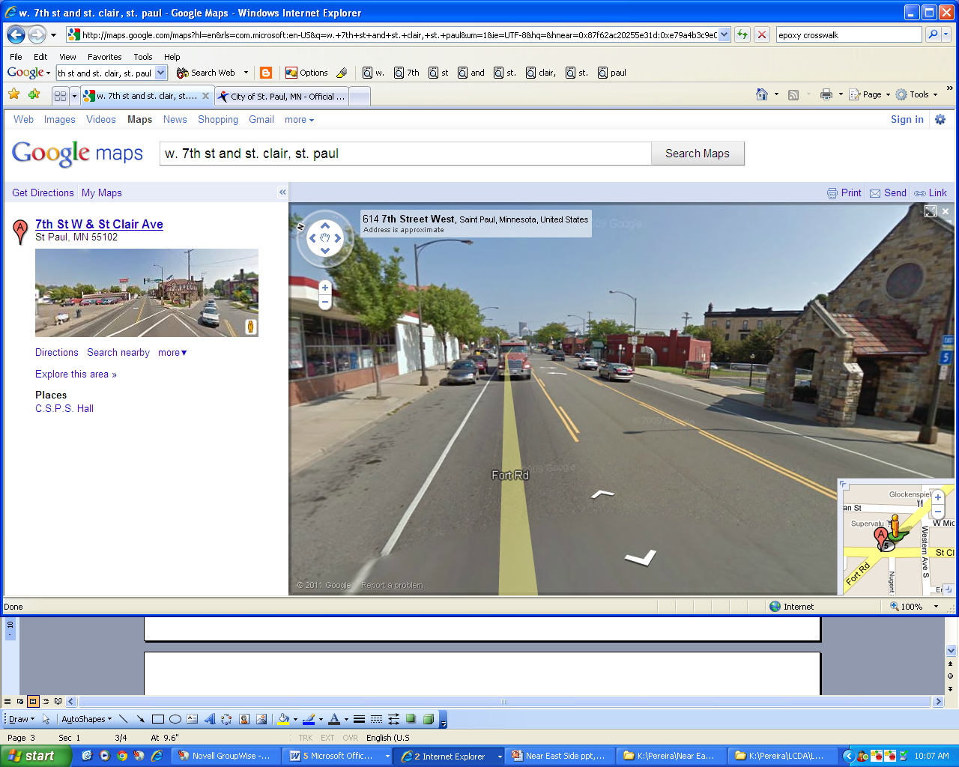
Regarding the re-design of crosswalks, because MNDOT expects the City’s Public Works Dept. to handle crosswalk maintenance, MNDOT only approves a crosswalk re-design if Public Works is on board with the maintenance implications. MNDOT prefer the use of stamped concrete that mimics brick over the use of pavers (which have higher maintenance costs). If crosswalks are painted or make use of epoxy, MNDOT recommends that these treatments only be installed at locations where intersections or crosswalks are signalized. The City of Saint Paul City's Public Works Traffic Division does not allow for painting crosswalks (other than the parallel lines) due to traffic safety reasons, with the possible exception of crosswalks across low volume, residential streets.
West 7th Street current 3-lane cross-section (10,300 ADT in 2008). Consists of two travel lanes, a center turn lane, and on-street parking on both sides of the street in most locations.

Regarding the expansion of sidewalks, MNDOT is generally okay with this as long as it does not take away from existing travel lanes. However, MNDOT is open to looking at a 4- to 3-lane street conversion, depending on traffic volumes. The typical average daily traffic (ADT) volume threshold to consider is 15,000 vehicles a day on a particular street segment, though MNDOT is open to discussing various options with the City. Exceptions can be made for street segments that exceed the 15,000 ADT threshold in very localized areas, though if ADT is closer to 20,000 vehicles/day, it may be a tougher sell for MNDOT.

