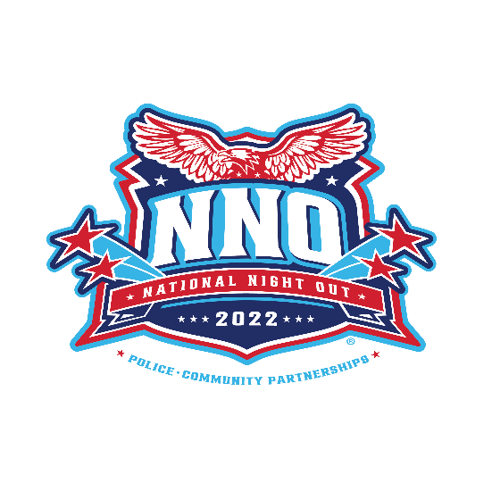
Business Name
Attn: owner/manager
Address

Dear owner/manager:

Our community is planning a local National Night Out Celebration. National Night is celebrated across the country on the 1st Tuesday of August each year. Millions of people participate in events. Our area is participating by : describe your event.

We asking for your support of the event by : your donation request. Your support would be greatly appreciated and help us create a better celebration of police community partnership and neighbors getting to know each other.

I can be contacted at (email) and (phone) with any questions. We are excited about this opportunity and the impact National Night Out has on our community.

Thank You,
Your Name

