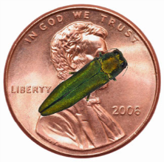**Emerald Ash Borer**

**Frequently Asked Questions**

**Parks and Recreation – Forestry, Version May 2018**

**Why the concern over emerald ash borer (EAB)?**

* **EAB has now advanced to the critical stage!**
* **EAB kills all ash trees**, *Fraxinus spp.*, native to North America that are not treated with an insecticide.
* Saint Paul’s urban forest is made up of approximately 20% of ash trees, with approximately 17,000 still on street boulevards and thousands more in residents’ private yards.
* EAB has now been found in every Saint Paul neighborhood, infesting both public and private trees. It is expected that all these trees, if untreated, will die within the next few years if not already.
* Minnesota, further, has the largest population of ash trees of any state in the nation at over 998 million. As of December 2017, EAB has spread to 16 counties within the state.
* According to the National Tree Benefit Calculator, a 15” diameter green ash tree provides about $147 in a multitude of benefits every year. Thus, the widespread loss of ash trees will be devastating environmentally, economically and socially to communities, cities and our entire state.

**What is emerald ash borer (EAB)?**

* Emerald ash borer (EAB), *Agrilus planipennis* Fairmaire, is an invasive tree pest from Asia that has been found in twenty-nine states and two Canadian provinces as of April 2017.
* 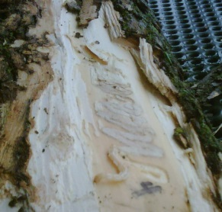Adult beetles are metallic green, are about 12 mm long and cause little damage themselves.
* However, EAB larvae feed for one or two years beneath the bark of ash trees, creating characteristic s-shaped galleries. It is the larvae feeding physical damage that ultimately kills the tree by destroying its ability to transport water and nutrients.
* Larvae grow and develop beneath the bark into adult EAB beetles that emerge in the spring, chewing D-shaped exit holes through the bark.
* Adult beetles mate and lay 40-70 eggs that hatch into immature larvae that burrow into the tree to feed.
* Without any natural controls or enemies, while EAB spread starts slowly—usually undetected—it reproduces exponentially and advances quickly to kill all a community’s ash trees, usually within 10-15 years.

**How did EAB arrive in Saint Paul and how long has it been here?**

* The first known EAB infestation in Minnesota was discovered in Saint Paul in the South Saint Anthony Park neighborhood in May 2009. However, it is believed that EAB arrived as early as 2004.
* It is believed that EAB became established in Saint Paul through human movement of infested wood and wood products (e.g.: firewood and pallets). Without the help of humans, EAB spreads less than a few miles a year.

**How do you identify an ash tree?**

* Leaves: Compound (several leaflets per stem), 8-12 inches long with 5-11 leaflets with smooth or finely toothed edges.
* Branching/buds: Opposite with a single bud, typically brown, at the end of the branch.
* Bark: Smooth on younger ash trees becoming ridged, diamond-shaped as tree matures.
* 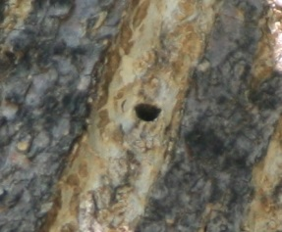[View more ash tree identification information](http://www.mda.state.mn.us/news/publications/ext/ashtreeid.pdf)

**How do you know if an ash tree is infested with emerald ash borer?**

* Signs of EAB include:
  + Small (1/8”) “D” shaped exit holes where beetles emerge (photo at right-not actual size).
  + Serpentine “S-shaped” larval galleries underneath the bark.
  + The presence of larvae or adult beetles. It is best to collect a sample and receive confirmation as these can often be confused with other *native* insects.

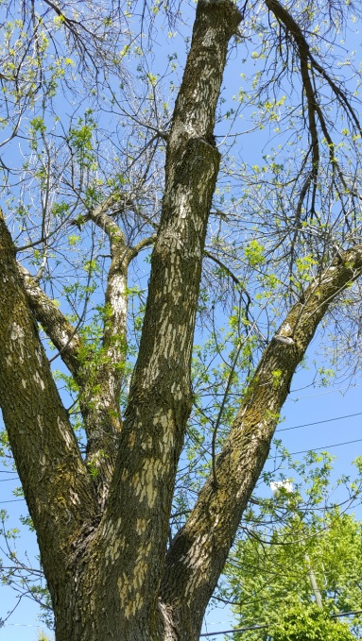

* Symptoms of EAB infestation include:
  + General thinning of canopy and increasing dieback until the tree is bare.
  + Increased woodpecker activity/damage is very common, but not indicative of EAB in an unhealthy ash tree.
  + Sprouting of new growth (epicormic sprouts).

**What should you do if you suspect a tree is infested with emerald ash borer?**

* Please review the above signs and symptoms of EAB.
* Contact Saint Paul Forestry at 651-266-6400 or e-mail [forestry@ci.stpaul.mn.us](mailto:forestry@ci.stpaul.mn.us) if you suspect a public ash tree to be infested with EAB in Saint Paul.
* If you suspect your private ash tree to be infested with EAB, contact a [licensed tree care company](https://www.stpaul.gov/departments/parks-recreation/natural-resources/forestry/tree-maintenance/licensed-tree-care).
* For trees outside of Saint Paul:
  + Contact Arrest the Pest @ Voicemail: 888-545-6684 or email: [arrest.the.pest@state.mn.us](mailto:arrest.the.pest@state.mn.us) (Note exact location and take a digital photo if possible) or download the [Great Lakes Early Detection Network](https://apps.bugwood.org/apps/gledn/) App for smartphone/devices.

**What should I be doing with my private ash tree(s)?**

* Because EAB has now advanced to the critical stage, it is important to take action now!
* View the [Homeowners Guide to EAB](https://www.stpaul.gov/departments/parks-recreation/natural-resources/forestry/homeowners-guide-eab) to learn more about management options for private property ash trees.
* Contact a [licensed tree care company](https://www.stpaul.gov/departments/parks-recreation/natural-resources/forestry/tree-maintenance/licensed-tree-care) once you decide to remove or treat your ash tree(s).
* Please know that dying ash trees dry out quickly and become brittle. They can drop limbs easily and become unpredictable. For this reason, they will also become more difficult and expensive to remove even for professionals. In other words, the longer you wait to take action, dire consequences increase.
* The city encourages residents to replant trees on their property after ash removal in order to take advantage of the countless economic, environmental and social benefits trees provide.

**How else can people help?**

* EAB is generally spread by people. Do not transport firewood—“Burn It Where You Buy It” unless it is MDA certified firewood (look for the MDA seal).
* Become knowledgeable about recognizing EAB and remain vigilant to the condition of your ash trees.
* Take care of the trees that are already in your yard. Have them properly pruned at the right time of year, water them when there is a drought (for mature trees), and mulch.
* Plant new trees and nurture them—regular watering and correctly mulching your new trees will help to ensure their survival.

***********************************************************************************************

**What is the City of Saint Paul doing in response to emerald ash borer?**

* The Department of Parks and Recreation – Forestry has been aggressively managing EAB since it was first discovered in 2009.
* The Saint Paul Emerald Ash Borer Management Program was created in June 2009 which was approved by the City Council to serve as a blue print for action. Refer to this [link](https://www.stpaul.gov/sites/default/files/Media%20Root/Parks%20%26%20Recreation/2017%20EAB%20Annual%20Report_2018%20Mgmt%20Recs_FINAL_.pdf) for the most current version of the management plan.
* The Emerald Ash Borer Management Program focuses on:
  + *Monitoring and Inspections:* survey to find infested public trees and new infestations in Saint Paul
  + *Removals:*
    - *Structured Removal:* proactive removal of ash trees (now primarily infested trees)
    - *Sanitation:* prompt removal and disposal of infested public trees
  + *Insecticide Treatments:* select public trees within infested areas are treated to reduce EAB population
  + *Inventory:* all public property boulevard trees are included in an inventory
  + *Reforestation:* with a goal of replanting a variety of species to increase diversity
  + *Outreach and Education:* in order to give citizens information on the pest
* Forestry monitors public ash trees throughout the city. When infested trees on public property are identified, efforts are made to remove them as promptly as possible.
* Forestry treats selected ash trees with an insecticide to reduce EAB population growth and mitigate removal costs.

**How does the city choose which ash trees to treat with insecticides?**

* Treated trees are selected based on the following criteria:
  + 10-20 inches in diameter at breast height (DBH)
  + Good health; without structural or other defects
  + Good site location: wide boulevard or park setting, no overhead utilities

**Why isn’t the city treating all of the public ash trees with insecticide?**

* Ash trees that are not structurally sound, are unhealthy or beneath overhead utilities do not warrant investment in insecticide treatment.
* Treating all ash trees is not cost effective due to the ongoing expense of the treatments.
* The goal of insecticide treatments by the city is to lengthen the response time to EAB infestations to one that is more manageable.

**Does the city use neonicotinoids to treat ash trees?**

* **NO.** Saint Paul does not use neonicotinoids to treat its ash trees. The city injects TREE-äge (active ingredient: Emamectin Benzoate), which is not in the neonicotinoid family of insecticides.

**Why is the city removing blocks of ash trees (Structured Removal)?**

* To mitigate the effects of EAB, the city began removing blocks of declining ash trees in order to reduce the number of trees requiring removal in the future. This management strategy has multiple benefits that include helping the City stay ahead of the pending crisis, spreading out the cost of removing thousands of expected dead trees, creates a more manageable and realistic financial plan, and allows for an increased diversity in the age and species of replanted trees.
* Beginning in 2017, Structured Removal of ash trees has transitioned to blocks of EAB-infested trees, whereas, in previous years removals mainly consisted of ash trees in declining health but not necessarily infested.
* There were about 27,000 boulevard ash trees alone in Saint Paul when EAB management began in 2009. Today there are about 17,000 remaining.
* Despite management efforts since 2010, only 1/3 of boulevard ash trees have been dealt with in eight years putting the city in a difficult position to deal with the other 2/3 in less time.

**How are residents or property owners informed that their block has been chosen for structured removal?**

* Residents are notified via U.S mail; postcards are mailed to all addresses on blocks that will be affected by structured removal (picture of actual postcard at right).

**What happens after the ash trees on Structured Removal streets are removed?**

* Currently, all of the stumps on Structured Removal streets will be removed when weather permits, usually the same year or following spring.
* A replacement tree may be planted by a contractor following the tree and stump removal. There are a few cases where a replacement tree would not be planted, but in general if a tree was removed, one will be planted.
* Replanting now emphasizes a diverse mix of species in order to decrease susceptibility to future invasive pests or pathogens.

**Why can’t the city wait for trees to die before removing them?**

* Dying and dead ash trees become brittle and unpredictable, posing significant hazard and liability from falling limbs and branches to both the public and tree service professionals.
* If delayed until the trees are dying from EAB, there could potentially be thousands more trees in need of removal at one time—a scenario that could not be handled sufficiently with currently allocated resources.
* Waiting for tree mortality is not considered a best management practice and does not mitigate the spread of EAB.
* Also if delayed until the trees are dead—potentially thousands of trees dead at once—tree and stump removal will not be timely, and replacement trees may not be planted until the more urgent matter of removals is resolved.
* Spreading out the cost of removals and replacement of ash trees over an extended time frame helps as:

a) budgets are not as severely impacted;

b) there are less ash trees that need to be managed, which is a costly task; and

c) possible hazardous situations will be lessened making public areas safer for citizens of Saint Paul.

**Is there a special assessment for Structured Removal of public boulevard ash trees?**

* There is no special assessment for this work. Property owners already pay for this work through taxes.

**Why are ash trees removed in construction projects?**

* In areas where streets are being torn up and re-constructed, i.e., new pavement, curbs and utilities, Public Works and other large construction projects offer a logical opportunity to update infrastructure including boulevard trees that might need to be replaced.
* While efforts are generally made to preserve healthy trees in construction areas, trees in direct conflict with the construction, those in declining condition, trees with severe defects, or trees facing other issues such as EAB, are removed and replaced in the final landscaping phase (the end) of the construction project.
* The University of Minnesota conducted a study in Minneapolis after a large storm event that found a direct correlation between construction-related severing of tree roots and subsequent tree failure (uprooting) due to instability. Thus, larger trees are highly susceptible to construction damage and require extra scrutiny.
* Regarding ash trees specifically, considering the impacts of construction, the inevitability of death from EAB, and the efficiencies gained through project collaboration, using construction projects as an opportunity for additional EAB management efforts is a smart use of taxpayer funds. Thus, ash tree removal and replacement became a regular part of construction projects starting in 2010.

For additional information on EAB, please visit our web site and links to other resources listed.