Bent Leg Slide
A good way to teach a bent leg slide is to teach it the way you teach many skills, in steps.
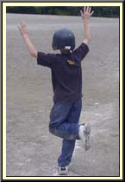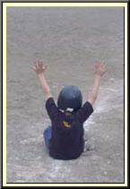
- Start by finding out which leg is going to be bent during the bent leg slide. With the player standing have him stand on one leg and bend the other leg at the knee, bringing it behind the other leg.
- Have the player raise both hands over his head.
- Have the player start to squat, while he keeps his bent leg up, then sit down. The player will naturally roll back on his back and his feet will come up in the air. Although this won't happen when he slides, it will during this stage. When he has rolled back to a seated position, he should still have their hands up and his front leg should be bent not straight.
- Once comfortable with this, have him take a couple steps and slide (I always practice sliding on grass). Then have them jog and slide and finally run full speed and slide.
Checkpoints for each step:
- Hands should above head not on the ground. Don't worry too much about how high the hands are. Keeping them above the head is used to avoid the natural reaction to put them on the ground.
- Player should be sliding on his butt, not side.
- Front leg should be bent to allow for give when sliding into the base.
Unless you're stealing second, don't slide head first into second base. The chances of being stepped on and injured are too great. For younger players, the head first slide is not recommended for anything other than diving back to first. A head first slide puts you in a vulnerable position where it is easy to injure your hands, shoulders, and head. A good bent leg slide straight into the base is the best and safest way to get to the bag, protect yourself, and break up a double play.
Go to any youth baseball game and you'll see players who have scrapes all over their legs from sliding. Player's mistakenly think that a bent leg slide is performed by sliding on the side of the leg. The proper way is to slide on your butt. Practice sliding in grass and check the stains on your pants. If they are on the side of your leg, you're not sliding properly. Another common problem in sliding is putting your hand down during the slide. This is often the cause of jammed fingers, wrists, and sometimes shoulders. Get in the habit of sliding with your hands up. If you can remember to slide on your butt with your hands up, you will be sliding pain free from that point on.

