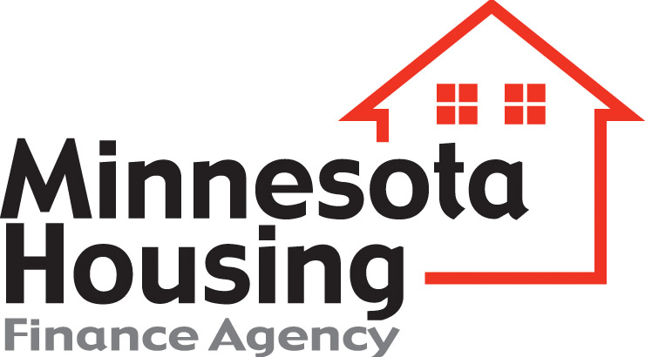 | Equal Employment Opportunity  Policy Statement

Development Information
Minnesota Housing Development Number
Development Name
Development Address
Total Number of Units
Dollar Amount of Rehab $ | Dollar Amount of Project $

Property Owner Information
Property Owner Name
Phone Number
Minority Property Owner? | No Yes, please enter racial/ethnic code:

Development Team Information
Equal Opportunity Officer Name
Phone Number
General Contractor Name
Phone Number
Minority General Contractor? | No Yes, please enter racial/ethnic code:

Racial/Ethnic Codes
1. Black or African American 2. Asian
3. American Indian or Alaskan Native 4. Native Hawaiian or Other Pacific Islander
5. Hispanic or Latino

Policy Statement
I hereby certify that it is the policy of the undersigned to comply with all existing laws prohibiting discrimination in all aspects of employment due to race, color, creed, sex, age, religion, familial status, sexual orientation, national origin, marital status, status with regard to public assistance, or disability. This shall be accomplished substantially by the following actions: Nondiscrimination in RECRUITING, HIRING, TRAINING, PROMOTING, SUBCONTRACTING, DEMOTION, LAYOFF, and/or TERMINATION. Whenever possible, we will also take affirmative action to include in our workforce minorities, females, and those who are disabled.

Property Owner or General Contractor Signature (entity completing form) | Date

Equal Opportunity Officer Signature | Date

Minnesota Housing Finance Agency (Minnesota Housing) is committed to equal housing and equal employment opportunity. Anyone that does business with Minnesota Housing will be required to share this commitment. Equal Opportunity Housing and Equal Opportunity Employment.

