How to Benchmark a Building

For Saint Paul’s 2019 Race to Reduce
This guide is intended for use by buildings participating in Saint Paul’s Race to Reduce. To qualify for basic recognition in the program, participating buildings must report both 2017 and 2018 energy and water usage for the whole building.

How to Use this Guide:
- If you have never benchmarked your building before, begin with Step 1, below.
- If you have already benchmarked your building’s 2017 and 2018 energy and water usage using Energy Star Portfolio Manager, skip to Step 4 below to enter your building’s unique property ID and submit your data.

Step 1 – Set Up Account
Set up your Energy Star Portfolio Manager Account.

Step 2 – Set Up Properties
Set up your Portfolio Manager properties by completing Page 1 of this guide, then return to Step 3, below.

Step 3 – Enter Usage Data
Don’t forget, you must submit 2017 and 2018 energy and water data to be recognized in the Race to Reduce!
Your usage data refers to energy and water consumption for your whole building. All Saint Paul buildings have electric and water usage. For heating, most properties use natural gas, although many downtown properties have District Energy.
After you confirm what services you receive, follow the steps to enter data for the period January 1, 2017 – December 31, 2018:
- Xcel Energy Electric and Natural Gas.
  - Electronic Data Transfer. If you have more than 4 tenants, we highly recommend using Xcel Energy’s Benchmarking Services User Guide to get your whole-building energy data automatically uploaded every month. The guide walks you through a multi-step process that must be followed exactly. If you get stuck, please contact our helpdesk.
  - Manual Data Entry. If you only have one meter, you may prefer to enter your data one month at a time. Follow the instructions here under “Entering Utility Data Manually.”

- Saint Paul Regional Water Services. From your Saint Paul Regional Water Services online account, select “usage history” from the left-hand menu. After you retrieve your water data, follow the instructions here.
- District Energy Saint Paul. District Energy customers should access copies of their bill or email District Energy requesting a spreadsheet containing 2017-2018 usage. The guidance below applies to either method:
  - Enter hot water and chilled water usage as two separate meters. Meter readings are located on the 2nd page of your bill. Please note the energy units in which energy is measured, as these are needed when setting up your meters in Portfolio Manager. District Energy measures hot water use in MWh, which you will need to multiply by 3.413 to convert to MMBtu because Portfolio Manager does not offer MWh as unit of measure. Chilled water is expressed in ton-hours.
  - After you retrieve your District Energy data, follow the instructions here.

Step 4 – Enter Each Property’s Unique ID
For each property, locate your building ID. Adding this ID to your building ensures the energy and water usage is attributed to the correct building and is required. After you’ve located your ID, follow these steps:
- In Portfolio Manager, click on the “Details” sub-tab for your property.

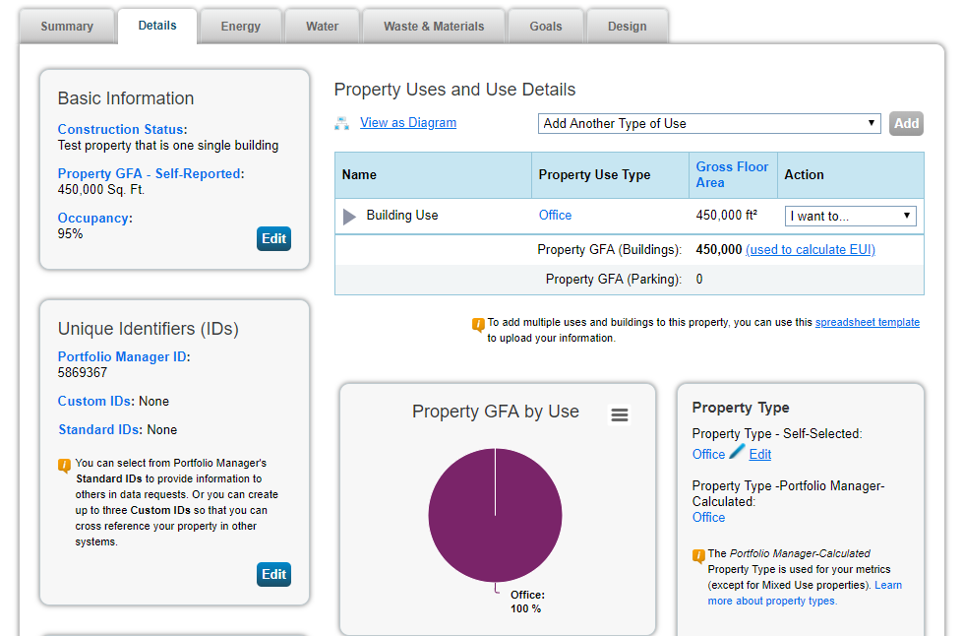
- Find the box titled “Unique Identifiers (IDs)” on the left side of the page, and click “Edit”.
- On the page that opens, scroll to the bottom to the box titled “Standard IDs”.
- In the alphabetical dropdown box, select “Minnesota Cities Energy Benchmarking Collaborative ID.”
- Enter your Minnesota Cities Energy Benchmarking Collaborative ID number from the building ID list and then click “Save.”

Step 5 – Run the Data Quality Checker
Once energy and water data for all of calendar year 2017 and 2018 has been entered in Portfolio Manager, owners must run the Data Quality Checker, a built-in tool in Portfolio Manager that identifies common errors, such as temporary values, default values, or less than 12 months of data.
- On the property’s Summary sub-tab, select “Check for Possible Errors.”
- Select “Dec 31” and the year you are reporting for then click “Run Checker.” You will need to perform this action twice, once for 2017 and again for 2018.
- Review the list of alerts (if any) and Portfolio Manager’s suggestions to address the issue(s).
  - Common alerts include temporary or estimated values or less than 12 full calendar months of energy bills.
  - You can ignore waste and materials meter alerts.
- Make corrections or updates to your property details to address as many alerts as possible and re-run the checker to confirm the alerts have been addressed.
- Repeat steps A-D for both 2017 and 2018 data.

Step 6 – Report 2017 and 2018 Data

To compete in the Race to Reduce, you must use Portfolio Manager to submit your energy and water to the city. This year, you will need to submit two full years of data to be recognized, 2017 and 2018. This requires repeating steps A-J below for each year, once for 2017 and once for 2018.
- To begin, click the reporting link for 2017.
Don’t forget, you must submit 2017 and 2018 energy and water data to be recognized in the Race to Reduce!
- Once signed in, the link will launch a page titled “Respond to Data Request.”
- At the bottom of the page, you will need to choose the properties to report using the drop-down menu and click “Generate Response Preview.”
- You will be taken to the Reporting tab with the response at the top of the table, highlighted. When you are ready to submit to the city, in the Action column, select “Send Response” from the dropdown.
- On the page that appears, you must electronically sign your report by entering your Portfolio Manager login information and clicking “E-Sign Response.” You have signed successfully when you see a green alert with a checkmark. See next page for further instructions.
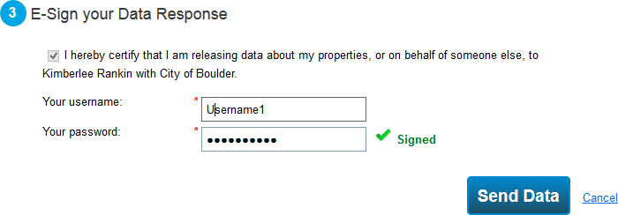
- Click “Send Data” and confirm submission by clicking “Continue.” Although your report has now been submitted to the city, you must report on 2018 as well to be recognized by the program.
- IMPORTANT: Repeat Step 6 parts B-F using the reporting link for 2018.
- You will receive a confirmation email from the EPA informing you that your data has been submitted to the Efficient Buildings Collaborative.
- You will also receive an official compliance notification email from the Efficient Buildings Collaborative after the city has reviewed the submission. Your building is not eligible for recognition for benchmarking until you receive that email for BOTH 2017 and 2018.

Need help?
Help is only a phone call or email away!
(866) 614-7542
benchmarking@ci.stpaul.mn.us

