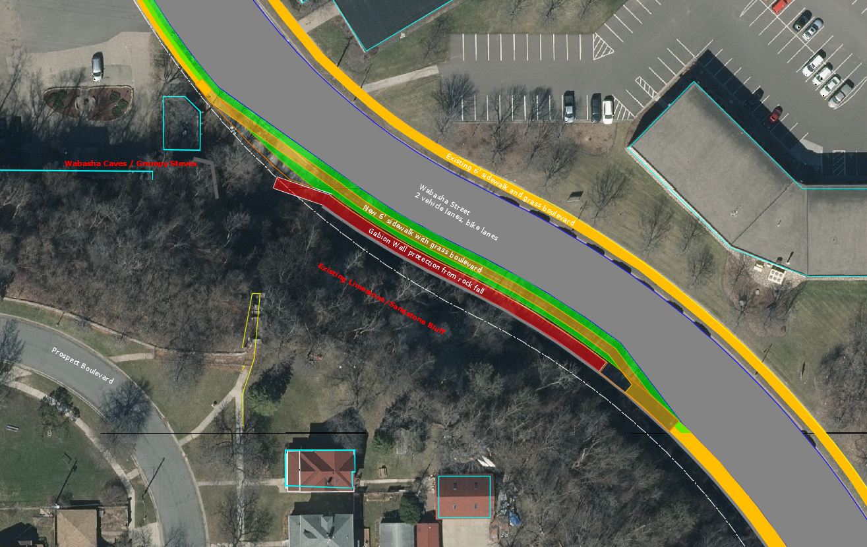
Figure 1. Plan layout of new gabion wall and road alignment.

