January 24, 2019

Dear Downtown Property Owner,

Downtown Saint Paul plays an important role in our city’s economic vitality. With all it has to offer, downtown Saint Paul is recognized as a great place to live, work and visit for fun and entertainment. We are investing in our downtown. In the coming months, the City of Saint Paul is launching a multi-year public works paving improvement project to improve the condition of all of our downtown streets and sidewalks. We will work with Saint Paul business leaders, property owners and residents to:

* Execute a mill and overlay of all downtown streets (taking up the current pavement and putting down new asphalt)
* Replace sidewalks and curbs that are broken or in disrepair
* Improve pedestrian safety by constructing ADA compliant curb ramps at intersections
* Make additional pedestrian safety improvements at identified intersections

The first phase of the project is scheduled to begin in 2019, and will include improving all streets and sidewalks east of Jackson Street – the Lowertown area of downtown.

Please join us for one of these Community Meetings to learn more about the 2019 Downtown Paving & Sidewalk Improvement Project:

**Tuesday, February 19, 2019 Tuesday, February 19, 2019**

**10:00 - 11:00 a.m. OR 5:30-6:30 p.m.**

**180 East 5th Street, 2nd Floor Conference Room 180 East 5th Street, 2nd Floor Conference Room**

At these meetings, Saint Paul Public Works will provide a broad overview of the project including the scope of the work, approximate timelines, and a block-by-block map outlining the work to be done on sidewalks. Although the city has mapped areaways under the sidewalks, please bring any information you have about areaways or vaults on your property. Saint Paul Public Works will have staff at the meeting to answer any initial questions. For basic project information, please see the enclosed “Frequently Asked Questions” document.

Thank you,

 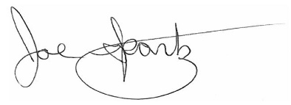 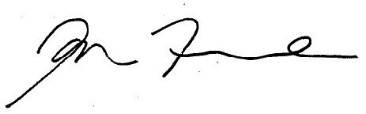

Kathy Lantry, Director of Public Works Joe Spartz, President Jon Fure, Executive Director

City of Saint Paul Saint Paul BOMA CapitolRiver Council

Enclosure